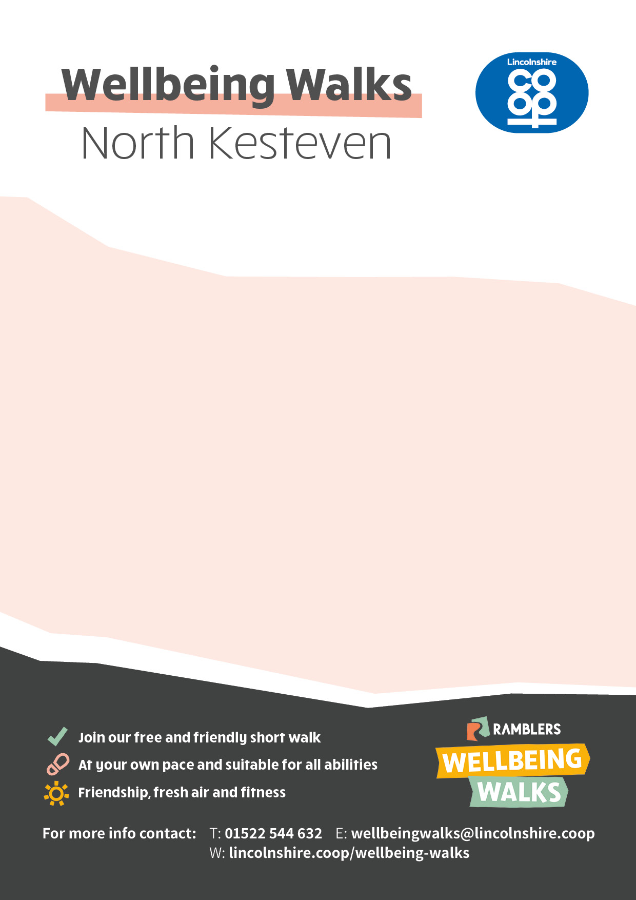

MONDAY (excludes bank holidays)

**North Hykeham,** **10am** - One NK Leisure Centre (inside foyer), Moor Lane, LN6 9AX

**Whisby Visually Impaired Walk,** **10.30am** -Whisby Nature Park,

Natural World Centre, Moor Lane, LN6 9BW

TUESDAY

**Heckington,** **10.30am** – St Andrews Church, NG34 9RF

**Leasingham,** **11am** – Village Hall, Chapel Lane, NG34 8GQ

**Sleaford,** **1.10pm** – The Hub, Navigation Wharf, NG34 7TW

WEDNESDAY

**Ruskington,** **1.30pm** – Church Bridge, by All Saints Church. Chapel Street, NG34 9DX

**Walcott,** **9.30am** - (1st & 3rd Wednesday of every month). St Oswald’s Church, High Street, LN4 3SW

**Martin, 9.30am** - (2nd & 4th Wednesday of every month). Village Hall, High Street, LN4 3QT

THURSDAY

**Waddington,** **10am** – Village Hall, Mere Road, LN5 9NX

**Branston, 10am** -(2nd and 4th Thursday of every month). Village Hall, Lincoln Road, LN4 1NS

**Skellingthorpe,** **11am** - Community Centre, Lincoln Road, LN6 5UT

**Sleaford,** **1**.**30pm** – Leisure Centre car park, Boston Road, NG34 7HH

FRIDAY

**Metheringham,** **10am** – Sports Pavilion, Princes Street, LN4 3DE

**Navenby,** **10.15am** – The Venue, Grantham Road, LN5 0JJ

**Whisby,** **10.30am** - Whisby Nature Park, Natural World Centre, Moor Lane, LN6 9BW